- NIKE, Inc. WACC Components Data
- Fiscal Year Ended: May 31, 2025

- 1. COST OF EQUITY COMPONENTS
Data Point | Value | Location in 10-K
Effective Corporate Tax Rate | 17.1% | Note 7 - Income Taxes; Consolidated Statements of Income
Dividend History
- FY2025 | $1.57 per share | Consolidated Statements of Shareholders' Equity
- FY2024 | $1.45 per share | Consolidated Statements of Shareholders' Equity
- FY2023 | $1.325 per share | Consolidated Statements of Shareholders' Equity
Earnings Per Share (Diluted) | $2.16 | Consolidated Statements of Income
Shares Outstanding
- Class A Common Stock | 290 million shares | Consolidated Balance Sheets
- Class B Common Stock | 1,186 million shares | Consolidated Balance Sheets
- Total Basic Shares | 1,484.9 million (weighted avg) | Note 10 - Earnings Per Share
- Total Diluted Shares | 1,487.6 million (weighted avg) | Note 10 - Earnings Per Share
Retained Earnings | $(727) million (deficit) | Consolidated Balance Sheets

- 2. COST OF DEBT COMPONENTS
Bond Issue Details | Original Principal | Interest Rate | Maturity Date | Book Value (May 31, 2025)
Corporate Term Debt:
Notes due 2026 | $1,000 million | 2.38% | November 1, 2026 | $999 million
Notes due 2027 | $1,000 million | 2.75% | March 27, 2027 | $999 million
Notes due 2030 | $1,500 million | 2.85% | March 27, 2030 | $1,495 million
Notes due 2040 (with swap)* | $1,000 million | 3.25% | March 27, 2040 | $993 million
Notes due 2043 (with swap)* | $500 million | 3.63% | May 1, 2043 | $502 million
Notes due 2045 (with swap)* | $1,000 million | 3.88% | November 1, 2045 | $997 million
Notes due 2046 | $500 million | 3.38% | November 1, 2046 | $493 million
Notes due 2050 | $1,500 million | 3.38% | March 27, 2050 | $1,483 million
Total Long-Term Debt | $8,000 million |  |  | $7,961 million
*Interest rate swaps: $2.4 billion notional amount of bonds have been swapped from fixed to variable rates (SOFR-based), with effective interest rates ranging from 3.6% to 4.5%.
Additional Debt Information | Value | Location in 10-K
Total Debt (Book Value) | $7,961 million | Note 6 - Long-Term Debt; Consolidated Balance Sheets
Fair Value of Debt | $6,673 million | Note 6 - Long-Term Debt
Current Portion of Long-Term Debt | $0 million | Consolidated Balance Sheets
Interest Expense (Net) | $(107) million (net income) | Consolidated Statements of Income
Cash Interest Paid | $389 million | Consolidated Statements of Cash Flows

- 3. COST OF PREFERRED STOCK
Data Point | Value | Location in 10-K
Preferred Stock Outstanding | $0.3 million (immaterial) | Note 8 - Redeemable Preferred Stock
Dividend Rate | $0.10 per share annually | Note 8 - Redeemable Preferred Stock
Weight in Capital Structure | ~0% (immaterial) | Note 8 - Redeemable Preferred Stock
Note: Redeemable preferred stock is owned by Sojitz Corporation of America, has a par value of $1 per share aggregating $0.3 million, and is immaterial to WACC calculation.

- 4. CAPITAL STRUCTURE (as of May 31, 2025)
Component | Book Value | Location in 10-K
Shareholders' Equity:
- Common Stock (Class A & B) | $3 million | Consolidated Balance Sheets
- Capital in Excess of Stated Value | $14,195 million | Consolidated Balance Sheets
- Accumulated Other Comprehensive Loss | $(258) million | Consolidated Balance Sheets
- Retained Earnings (Deficit) | $(727) million | Consolidated Balance Sheets
Total Shareholders' Equity | $13,213 million | Consolidated Balance Sheets
Long-Term Debt | $7,961 million | Consolidated Balance Sheets
Current Portion of Long-Term Debt | $0 million | Consolidated Balance Sheets
Notes Payable | $5 million | Consolidated Balance Sheets
Total Debt | $7,966 million | Consolidated Balance Sheets
Total Capitalization (Book Value) | $21,179 million | Calculated from Balance Sheet
Weights for WACC Calculation (Book Values):
- Equity Weight: 62.4% ($13,213 / $21,179)
- Debt Weight: 37.6% ($7,966 / $21,179)

- 5. FINAL WACC CALCULATION INPUTS
Formula:
text
WACC = (E/V × Cost of Equity) + (D/V × Cost of Debt × (1 - Tax Rate)) + (P/V × Cost of Preferred Stock)
Available Inputs:
Input | Value | Source
E = Market Value of Equity | Requires current stock price × diluted shares outstanding | External market data needed
D = Market Value of Debt | $6,673 million (fair value) | Note 6 - Long-Term Debt
P = Preferred Stock | ~$0 (immaterial) | Note 8 - Redeemable Preferred Stock
Effective Tax Rate | 17.1% | Note 7 - Income Taxes
Federal Income Tax Rate | 21.0%
State Taxes | 2.0%
Book Value of Equity | $13,213 million | Consolidated Balance Sheets
Diluted Shares Outstanding | 1,487.6 million | Note 10 - Earnings Per Share

- ADDITIONAL CONTEXT:
Fiscal 2025 Financial Performance:
- Total Revenues: $46,309 million
- Net Income: $3,219 million
- EBIT: $3,778 million
- EBIT Margin: 8.2%
- Cash and Equivalents: $7,464 million
- Total Assets: $36,579 million
Credit Ratings (as of July 2025):
- Standard & Poor's: A+ (downgraded from AA-)
- Moody's: A1

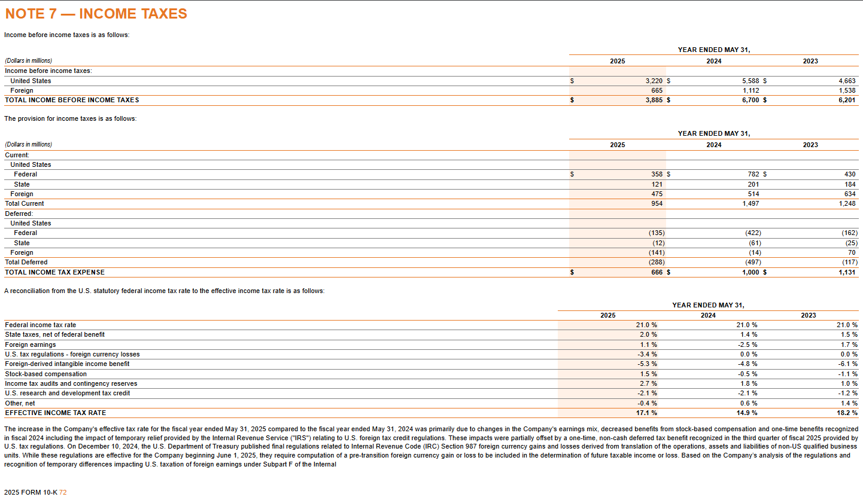
Document Reference:
NIKE, Inc. Form 10-K for Fiscal Year Ended May 31, 2025
Filed: July 17, 2025
Accession Number: 0000320187-25-000047

All data points have been extracted directly from NIKE's official SEC 10-K filing and are referenced to their specific locations within the document for verification purposes.

